The initial theory that the environment can bring about changes in individuals was proposed by:
A. Jan Zacharias
B. Lyell
C. Malthus
D. Lamarck
ANSWER: D
Philosophie Zoologique was the book of:
A. Darwin
B. Weismann
C. Lamarck
D. Suarez
ANSWER: C
_________ was an early proponent of the idea that evolution occurred
A. Jan Zacharias
B. Lyell
C. Malthus
D. Lamarck
ANSWER: D
___________ regarded as a premier authority on invertebrate zoology
A. Jan Zacharias
B. Lyell
C. Jan Ingenhousz
D. Lamarck
ANSWER: D
In 1809, Lamarck published the book
A. Origin of species
B. Principle of geology
C. Philosophie Zooloqique
D. Population dynamics
ANSWER: C
The ideas about evolution presented by Lamarck are known as
A. Darwinism
B. Neo-Darwinism
C. Lamarckism
D. Germinal continuity theory
ANSWER: C
_________ pictured evolution as a "ladder of life" from simplest to the most complex animals
A. Jan Zacharias
B. Lyell
C. Jan Ingenhousz
D. Lamarck
ANSWER: D
Inheritance of acquired character theory was presented by:
A. Darwin
B. Lamarck
C. Mendel
D. Weismann
ANSWER: B
________contribution to science is important because he was the first to propose that organisms undergo change over time as a result of some natural phenomena
A. Darwin
B. Lamarck's
C. Mendel
D. Weismann
ANSWER: B
The point “use and disuse of organs” was presented by:
A. Darwin
B. Lamarck
C. Mendel
D. Weismann
ANSWER: B
Which of the following are important point(s) of Lamarck's theory?
A. Use and disuse of organs
B. Inheritance of acquired characters
C. Natural selection
D. Both A and B
ANSWER: D
Match the scientists and their contributions in the field of evolution.
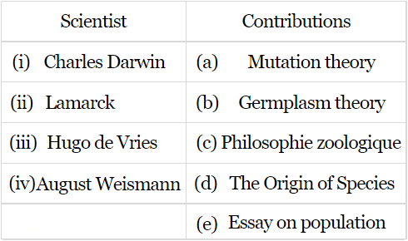
A. (i)-(d), (ii)-(c), (iii)-(a), (iv)-(e)
B. (i)-(a), (ii)-(d), (iii)-(a), (iv)-(c)
C. (i)-(e), (ii)-(d), (iii)-(a), (iv)-(c)
D. (i)-(d), (ii)-(c), (iii)-(a), (iv)-(b)
ANSWER: D
Inheritance of acquired character theory was presented by:
A. Darwin
B. Lamarck
C. Mendel
D. Weismann
ANSWER: B
Lamarck’s theory does not include this point:
A. Natural selection
B. Effect of environment
C. Inheritance of acquired character
D. Use and disuse of organs
ANSWER: A
In Lamarck’s view, the key to organic evolution is that each progeny
A. shows the struggle for existence
B. characters acquired by parental generation are inherited
C. is similar to its parents
D. phylogeny is repeated in its ontogeny
ANSWER: B
This is a most popular example of Lamarck
A. Primrose
B. Snakes
C. African Giraffe
D. Both (b) and (c)
ANSWER: D
The idea of use and disuse of organs was given by
A. Lamarck
B. Morgan
C. Darwin
D. Hugo de Vries
ANSWER: A
Who stated this theory – organ in use will develop and if not used will weaken to turn vestigial
A. Mendel
B. De Vries
C. Darwin
D. Lamarck
ANSWER: D
Lamarck's theory of organic evolution was published in the book entitled:
A. Systema Nature
B. Philosophic Zoologique
C. Origin of species
D. None of these
ANSWER: B
Lamarck's "Theory of Organic Evolution" is based upon:
A. Effect of environment
B. Use and disuse of body parts
C. Inheritance of acquired characters
D. All of these
ANSWER: D
Best-suited examples given in favor of Lamarckian Theory are:
A. Elongation of neck and fore limbs of African giraffe
B. Loss of limbs in snakes
C. Both (a) & (b)
D. None of these
ANSWER: C
Neck and fore limbs in African giraffe increased in length as a result of:
A. Variation in these organs
B. Mutations in these organs
C. Use and disuse
D. None of these
ANSWER: C
Which of the following concepts is attributed to Lamarck:
A. Struggle for existence
B. Survival of the fittest
C. Inheritance of acquired characters
D. Cells come from pre-existing cells
ANSWER: C
By illustrating the examples of African giraffe and snakes Lamarck emphasized mainly that:
A. Nature selects the forms which are fittest in the struggle for existence
B. Development and efficiency of body organs are an proportion to their use and disuse
C. Variations (environmental or mutations) are respobsible for process of organic evolution
D. The organisms have enormous fertility leading to over production but their number is always kept constant by the nature
ANSWER: B
This is a most popular example of Lamarck
A. Primrose
B. Snakes
C. African Giraffe
D. Both (b) and (c)
ANSWER: D
Neck and fore limbs in African giraffe increased in length as a result of:
A. Variation in these organs
B. Mutations in these organs
C. Use and disuse
D. None of these
ANSWER: C
By illustrating the examples of African giraffe Lamarck emphasized mainly that:
A. Nature selects the forms which are fittest in the struggle for existence
B. Development and efficiency of body organs are an proportion to their use and disuse
C. Variations (environmental or mutations) are respobsible for process of organic evolution
D. The organisms have enormous fertility leading to over production but their number is always kept constant by the nature
ANSWER: B
An example often used to illustrate Lamarck's hypothesis involves
A. The evolution of tail of mice
B. The evolution of the giraffe's long neck from short-necked ancestors
C. The evolution of the beak of finches
D. The evolution of horse
ANSWER: B
____________constantly stretch their neck in order to reach the leaves at the top of trees
A. Snake
B. Giraffe
C. Bird
D. Horse
ANSWER: B
Neck stretching in Lamarckism is:
A. An adopted trait
B. An inherited characterizes
C. An acquired characteristic
D. A result of divergent evolution
ANSWER: C
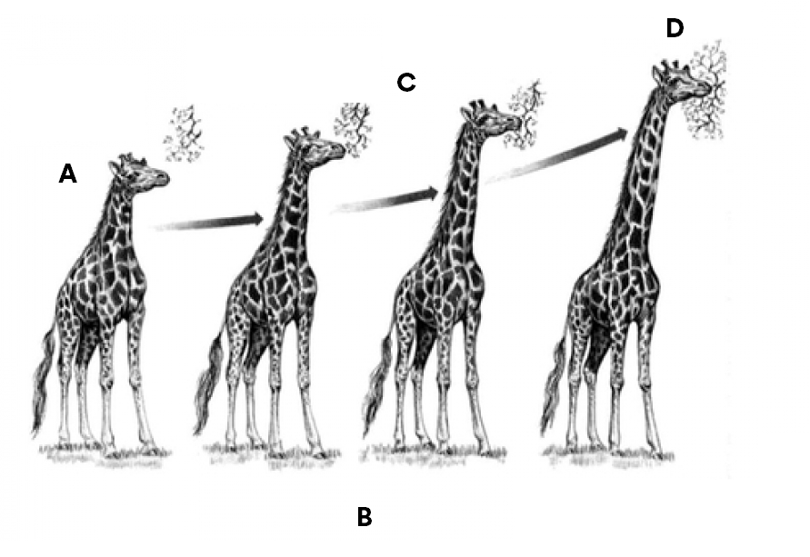
The evolution of the giraffe is an example of:
A. Germinal continuity theory
B. Inheritance of acquired character
C. Mutation theory
D. Natural selection
ANSWER: B

In the above diagram, what does A represent?
A. Stretching neck to reach higher leaves on trees
B. Original short-necked ancestor
C. Stretching until neck becomes progressive longer
D. Evolution of giraffe
ANSWER: B

In the above diagram, what does C represent?
A. Stretching neck to reach higher leaves on trees
B. Original short-necked ancestor
C. Neck becomes progressive longer
D. Evolution of giraffe
ANSWER: A

In the above diagram, what does D represent?
A. Stretching neck to reach higher leaves on trees
B. Original short-necked ancestor
C. Neck becomes progressive longer
D. Evolution of giraffe
ANSWER: C
Acquired characteristics of Lamarck are not inherited and have an evolutionary value. Who gave this statement?
A. Weismann
B. Hugo de Vries
C. TH Morgan
D. Charles Darwin
ANSWER: A
Germplasm theory against Lamarck’s principle was put forward by
A. Darwin
B. Lamarck
C. Weismann
D. Hugo de Vries
ANSWER: C
Weismann strongly opposed and rejected
A. Lamarckian theory
B. Darwin theory
C. De Vries
D. All of these
ANSWER: A
Greatest blow to Lararckism came from the work of:
A. Charles Darwin
B. August Weismann
C. Hugo De 'Vries
D. Alfred Russell Wallace
ANSWER: B
From the experiments upon mice by cutting the tails of new-born mice for more than twenty generations and yet no hereditary effect, Weismann could conclude:
A. "Theory of survival of fittest"
B. "Theory of continuity of germplasm"
C. "Inheritance of acquired characters"
D. "Isolation plays significant role in evolution"
ANSWER: B
The anatomical, biochemical and behavioral characteristics that an individual organism displays as it develops through life is known as its
A. Genotype
B. Phenotype
C. Gene
D. Gene pool
ANSWER: B
The phenotype that an individual actually develops is somewhat conditional and is based:
A. The fixed genetic potential of the organism
B. Its genotype; this refers to the specific qualities of its genetic material or DNA
C. The environmental conditions which an organism experiences as it grows
D. All of these
ANSWER: D
The point of Lamarckism i.e., use and disuse of organs may be acceptable but the characteristics which are acquired through this process during the lifetime have
A. Genetic basis and can be inherited to the next generation
B. No genetic bases and can be inherited to the next generation
C. No genetic bases and therefore cannot be inherited to the next generation
D. The fixed genetic potential of the organism
ANSWER: C
The mechanism of inheritance, which is proposed by Mendel
A. Jan Zacharias
B. Lyell
C. Malthus
D. Mendel
ANSWER: D
The mechanism of inheritance, which is proposed in
A. 1865
B. 1878
C. 1872
D. 1898
ANSWER: A

